7. Roadmap and Timeline
The AI Gateway is developed in Task 3.4 from M01 to M36. Deliverable D3.1, Design of the AI gateway, is due in M03. With the project starting on 1 May 2026, the principal month markers are M03 = July 2026, M12 = April 2027, M18 = October 2027 and M36 = April 2029. The contractual Gateway milestones and deliverables are separated below from the indicative internal implementation stages.

7.1 Indicative implementation stages
The stages in Table 7.1 organise the broad target scope into an implementable sequence. They are planning stages rather than additional contractual deliverables. Priorities may be adjusted after stakeholder validation, proof-of-concept results, infrastructure constraints and risk review.
Stage | Indicative window | Primary focus | Contractual anchor
Initial design | M01-M03 | Consolidate the project context, domain and system use cases, candidate technologies, roadmap and risks. | D3.1 and MS01 in M03.
Beta implementation | M04-M12 | Implement and integrate the minimum coherent user path: identity and access, portal and catalogue, basic data/model access, basic inference or job execution, monitoring, notifications, and links to support and training. | MS10 and MS11 in M12.
Functionality consolidation | M13-M18 | Extend and validate Gateway functionalities and features, integrate selected domain workflows, strengthen monitoring and model/data lifecycle support, and execute federation proofs of concept. | D3.4 in M18.
Continued deployment and validation | M19-M36 | Continue hardening, operational improvement, interoperability, domain integration, user support, training integration, validation and benchmarking. | T3.4 and T3.5 continue through M36; no separate M36 Gateway deliverable is listed in the Annex.
Table 7.1. Indicative AI Gateway implementation stages.

7.2 Contractual deliverables and milestones
The deliverables and milestones that directly frame the Gateway are listed in Table 7.2. They are taken from the SAIFA implementation details; the wider WP3 plan is shown in Figure 7.1.
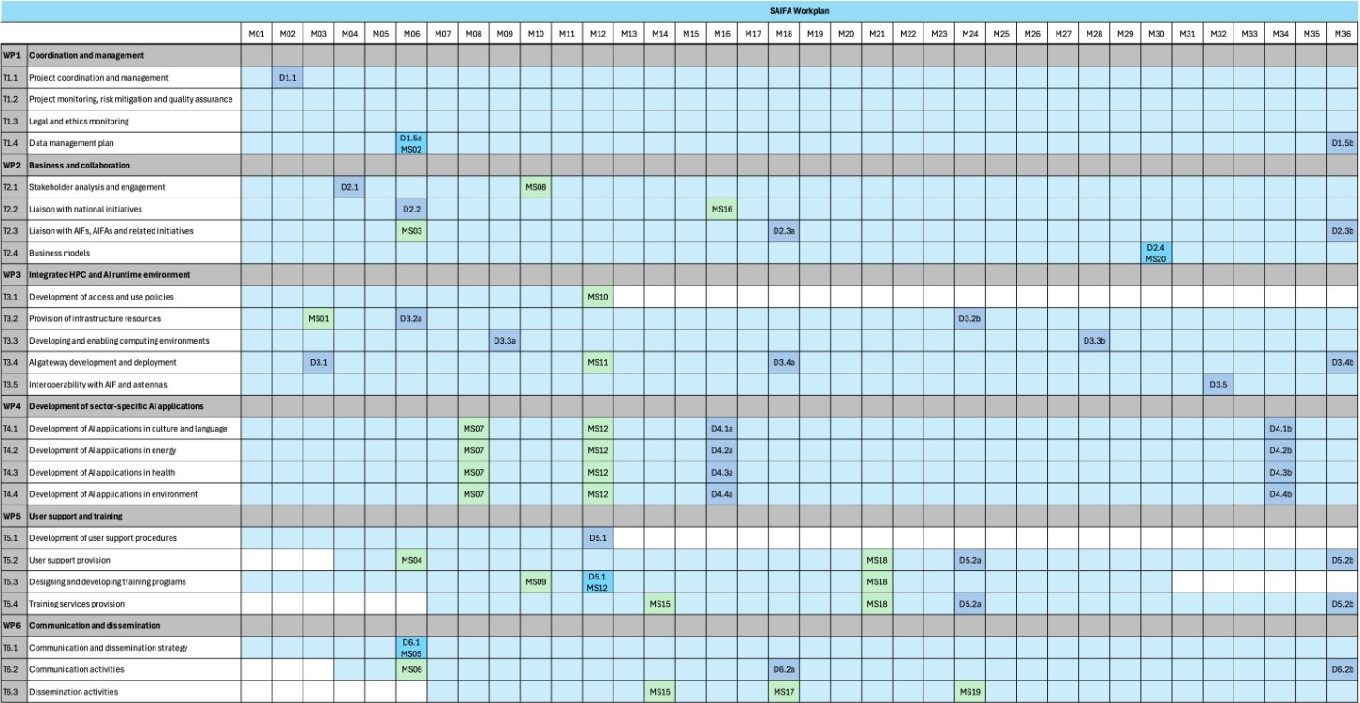
Figure 7.1. SAIFA implementation plan, highlighting WP3 and Task 3.4.
ID | Deliverable or milestone | WP / Task | Due | Means of verification
D3.1 | Design of the AI gateway | WP3 / T3.4 | M03 (Jul 2026) | Comprehensive development plan submitted as a public deliverable.
MS01 | Access to infrastructure provided | WP3 | M03 (Jul 2026) | User accounts created on the national infrastructure resources.
MS10 | Access and use policies | WP3 | M12 (Apr 2027) | Access and use policies available online.
MS11 | Beta version of AI gateway | WP3 / T3.4 | M12 (Apr 2027) | AI Gateway available online.
D3.4 | AI gateway functionalities and features | WP3 / T3.4 | M18 (Oct 2027) | Detailed overview of implemented Gateway functionalities and features submitted.
Table 7.2. Contractual deliverables and milestones relevant to the AI Gateway.

7.3 Testing and validation plan
Testing follows the two-stage model described in WP3: development, integration and preliminary validation on the national infrastructure, followed by final testing and performance benchmarking using the Greek and Italian AI Factory infrastructures. The principal activities are:
• Continuous development and integration testing (M01-M36). Gateway services and domain workflows are integrated and tested on PARADOX and the ITE AI infrastructure provided through T3.2 and T3.3.
• Internal validation before wider access. Consortium users, WP4 domain owners and WP5 support and training teams validate the agreed scenarios before they are opened to broader user groups.
• Beta validation (M12). MS11 demonstrates an online beta version together with the access and use policies delivered under MS10. The beta must support at least one coherent end-to-end path through identity, discovery, execution and monitoring.
• Functionality and feature validation (M18). D3.4 records the implemented functions and evidence obtained from integration, user and interoperability testing.
• Greek and Italian infrastructure testing. Access policies and integration protocols developed with the Pharos and IT4LIA teams are used for final testing and performance benchmarking of selected applications and Gateway interactions.
• Security, compliance and operational acceptance. Access control, auditability, data governance, transfer integrity, recovery and relevant legal and ethical conditions are verified before a function is accepted for external use.

